DEPARTMENT OF SOFTWARE ENGINEERING MOBILE APPLICATION DEVELOPMENT (SE-487)

**LAB SESSION 8**

**Lab Session on Rows and Columns**

**Objective:**

To understand the use of rows and columns for arranging widgets in a Flutter app **Introduction:**

In Flutter, a Column widget is a layout widget that arranges its children in a vertical sequence, one below the other. It is commonly used to create vertical layouts for organizing UI elements such as text, buttons, images, and other widgets in a Flutter app. The Column widget is flexible and allows developers to create complex UI designs by nesting multiple widgets within it. In Flutter, a Row widget is a layout widget that arranges its children in a horizontal sequence, one next to the other. It is commonly used to create horizontal layouts for organizing UI elements such as text, buttons, images, and other widgets in a Flutter app. The Row widget is flexible and allows developers to create complex UI designs by nesting multiple widgets within it.

**Details of Column/Row Widget:**

**Child Alignment:** The alignment of children inside a Column/Row can be controlled using the **mainAxisAlignment** and **crossAxisAlignment** properties.

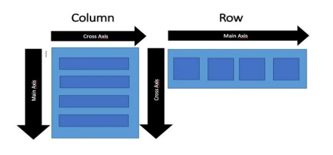

DEPARTMENT OF SOFTWARE ENGINEERING MOBILE APPLICATION DEVELOPMENT (SE-487)

import 'package:flutter/material.dart';

void main() { 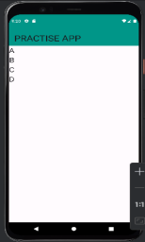

runApp(const MyApp());

}

class MyApp extends StatelessWidget {

const MyApp({super.key});

@override

Widget build(BuildContext context) {

return MaterialApp(

title:'flutter demo',

debugShowCheckedModeBanner: false,

theme:ThemeData(

primarySwatch:Colors.*lightBlue*,

),

home:const MyHomePage(),

);

}

}

class MyHomePage extends StatefulWidget {

const MyHomePage({Key?key}):super(key:key);

@override

State<MyHomePage> createState() => _MyHomePageState(); }

class _MyHomePageState extends State<MyHomePage>

{

@override

Widget build(BuildContext context) {

return Scaffold(

appBar: AppBar(

backgroundColor: Colors.*teal*,

title: Text('PRACTISE APP',style: TextStyle(fontSize: 30),),

),

body:

Column(

children: [

Text('A',style:TextStyle(fontSize: 25),), Text('B',style:TextStyle(fontSize: 25),), Text('C',style:TextStyle(fontSize: 25),), Text('D',style:TextStyle(fontSize: 25),),

],

)

);

DEPARTMENT OF SOFTWARE ENGINEERING MOBILE APPLICATION DEVELOPMENT (SE-487)

}

}

import 'package:flutter/material.dart'; 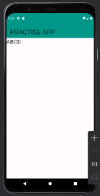

void main() {

runApp(const MyApp());

}

class MyApp extends StatelessWidget {

const MyApp({super.key});

@override

Widget build(BuildContext context) {

return MaterialApp(

title:'flutter demo',

debugShowCheckedModeBanner: false,

theme:ThemeData(

primarySwatch:Colors.*lightBlue*,

),

home:const MyHomePage(),

);

}

}

class MyHomePage extends StatefulWidget {

const MyHomePage({Key?key}):super(key:key);

@override

State<MyHomePage> createState() => _MyHomePageState(); }

class _MyHomePageState extends State<MyHomePage>

{

@override

Widget build(BuildContext context) {

return Scaffold(

appBar: AppBar(

backgroundColor: Colors.*teal*,

title: Text('PRACTISE APP',style: TextStyle(fontSize: 30),),

),

body:

Row(

children: [

Text('A',style:TextStyle(fontSize: 25),), Text('B',style:TextStyle(fontSize: 25),),

DEPARTMENT OF SOFTWARE ENGINEERING MOBILE APPLICATION DEVELOPMENT (SE-487)

Text('C',style:TextStyle(fontSize: 25),), Text('D',style:TextStyle(fontSize: 25),),

],

)

);

}

}

**mainAxisAlignment:** Determines how the children are aligned vertically/horizontally. Options include start, end, center, spaceBetween, spaceAround, and spaceEvenly.

import 'package:flutter/material.dart'; 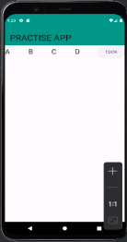

void main() {

runApp(const MyApp());

}

class MyApp extends StatelessWidget {

const MyApp({super.key});

@override

Widget build(BuildContext context) {

return MaterialApp(

title:'flutter demo',

debugShowCheckedModeBanner: false,

theme:ThemeData(

primarySwatch:Colors.*lightBlue*,

),

home:const MyHomePage(),

);

}

}

class MyHomePage extends StatefulWidget {

const MyHomePage({Key?key}):super(key:key);

@override

State<MyHomePage> createState() => _MyHomePageState(); }

class _MyHomePageState extends State<MyHomePage>

{

@override

Widget build(BuildContext context) {

return Scaffold(

appBar: AppBar(

backgroundColor: Colors.*teal*,

DEPARTMENT OF SOFTWARE ENGINEERING MOBILE APPLICATION DEVELOPMENT (SE-487)

title: Text('PRACTISE APP',style: TextStyle(fontSize: 30),),

),

body:

Container(

//width:300,

child: Row(

mainAxisAlignment: MainAxisAlignment.spaceBetween, children: <Widget> [

Text('A',style:TextStyle(fontSize: 25),), Text('B',style:TextStyle(fontSize: 25),), Text('C',style:TextStyle(fontSize: 25),), Text('D',style:TextStyle(fontSize: 25),), ElevatedButton(child: Text('CLICK'),onPressed:(){

print('hello');

},),

],

),

)

);

}

}

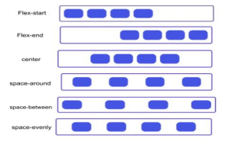

DEPARTMENT OF SOFTWARE ENGINEERING MOBILE APPLICATION DEVELOPMENT (SE-487)

import 'package:flutter/material.dart'; 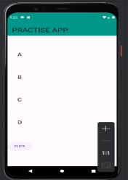

void main() {

runApp(const MyApp());

}

class MyApp extends StatelessWidget {

const MyApp({super.key});

@override

Widget build(BuildContext context) {

return MaterialApp(

title:'flutter demo',

debugShowCheckedModeBanner: false,

theme:ThemeData(

primarySwatch:Colors.*lightBlue*,

),

home:const MyHomePage(),

);

}

}

class MyHomePage extends StatefulWidget {

const MyHomePage({Key?key}):super(key:key);

@override

State<MyHomePage> createState() => _MyHomePageState(); }

class _MyHomePageState extends State<MyHomePage>

{

@override

Widget build(BuildContext context) {

return Scaffold(

appBar: AppBar(

backgroundColor: Colors.*teal*,

title: Text('PRACTISE APP',style: TextStyle(fontSize: 30),),

),

body:

Container(

//height: 500,

child: Column(

mainAxisAlignment: MainAxisAlignment.spaceEvenly, //crossAxisAlignment: CrossAxisAlignment.end , children: <Widget> [

Text('A',style:TextStyle(fontSize: 25),), Text('B',style:TextStyle(fontSize: 25),), Text('C',style:TextStyle(fontSize: 25),), Text('D',style:TextStyle(fontSize: 25),),

DEPARTMENT OF SOFTWARE ENGINEERING MOBILE APPLICATION DEVELOPMENT (SE-487)

ElevatedButton(child: Text('CLICK'),onPressed:(){ print('hello');

},),

],

),

)

);

}

}

**crossAxisAlignment:** Determines how the children are aligned horizontally/vertically. Options include start, end, center, stretch, and baseline.

import 'package:flutter/material.dart'; 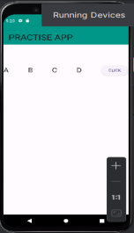

void main() {

runApp(const MyApp());

}

class MyApp extends StatelessWidget {

const MyApp({super.key});

@override

Widget build(BuildContext context) {

return MaterialApp(

title:'flutter demo',

debugShowCheckedModeBanner: false,

theme:ThemeData(

primarySwatch:Colors.*lightBlue*,

),

home:const MyHomePage(),

);

}

}

class MyHomePage extends StatefulWidget {

const MyHomePage({Key?key}):super(key:key);

@override

State<MyHomePage> createState() => _MyHomePageState(); }

class _MyHomePageState extends State<MyHomePage>

{

@override

Widget build(BuildContext context) {

DEPARTMENT OF SOFTWARE ENGINEERING MOBILE APPLICATION DEVELOPMENT (SE-487)

return Scaffold(

appBar: AppBar(

backgroundColor: Colors.*teal*,

title: Text('PRACTISE APP',style: TextStyle(fontSize: 30),),

),

body:

Container(

height: 200,

child: Row(

mainAxisAlignment: MainAxisAlignment.spaceBetween, crossAxisAlignment: CrossAxisAlignment.center, children: <Widget> [

Text('A',style:TextStyle(fontSize: 25),), Text('B',style:TextStyle(fontSize: 25),), Text('C',style:TextStyle(fontSize: 25),), Text('D',style:TextStyle(fontSize: 25),), ElevatedButton(child: Text('CLICK'),onPressed:(){

print('hello');

},),

],

),

)

);

}

}

import 'package:flutter/material.dart'; 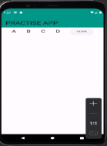

void main() {

runApp(const MyApp());

}

class MyApp extends StatelessWidget {

const MyApp({super.key});

@override

Widget build(BuildContext context) {

return MaterialApp(

title:'flutter demo',

debugShowCheckedModeBanner: false,

theme:ThemeData(

primarySwatch:Colors.*lightBlue*,

DEPARTMENT OF SOFTWARE ENGINEERING MOBILE APPLICATION DEVELOPMENT (SE-487)

),

home:const MyHomePage(),

);

}

}

class MyHomePage extends StatefulWidget {

const MyHomePage({Key?key}):super(key:key);

@override

State<MyHomePage> createState() => _MyHomePageState(); }

class _MyHomePageState extends State<MyHomePage>

{

@override

Widget build(BuildContext context) {

return Scaffold(

appBar: AppBar(

backgroundColor: Colors.*teal*,

title: Text('PRACTISE APP',style: TextStyle(fontSize: 30),),

),

body:

Row(

mainAxisAlignment: MainAxisAlignment.spaceEvenly, children: <Widget> [

Text('A',style:TextStyle(fontSize: 25),), Text('B',style:TextStyle(fontSize: 25),), Text('C',style:TextStyle(fontSize: 25),), Text('D',style:TextStyle(fontSize: 25),), ElevatedButton(child: Text('CLICK'),onPressed:(){

print('hello');

},),

],

)

);

}

}

**Spacing Between Children:** Developers can add spacing between children in a Column/Row using SizedBox or Container widgets with specific height values.

**Scrolling:** If the contents of a Column/Row exceed the available vertical space, it can be wrapped with a SingleChildScrollView to enable vertical scrolling.

DEPARTMENT OF SOFTWARE ENGINEERING MOBILE APPLICATION DEVELOPMENT (SE-487)

**Flexibility:** The Column/Row widget allows its children to expand to fill the available vertical space. Developers can control the flexibility of children using the Expanded or Flexible widgets.

**Nested Columns/Rows:** Column widgets can be nested within other Column widgets to create complex vertical layouts with multiple levels of hierarchy.

import 'package:flutter/material.dart'; 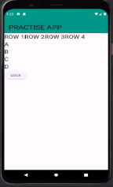

void main() {

runApp(const MyApp());

}

class MyApp extends StatelessWidget {

const MyApp({super.key});

@override

Widget build(BuildContext context) {

return MaterialApp(

title:'flutter demo',

debugShowCheckedModeBanner: false,

theme:ThemeData(

primarySwatch:Colors.*lightBlue*,

),

home:const MyHomePage(),

);

}

}

class MyHomePage extends StatefulWidget {

const MyHomePage({Key?key}):super(key:key);

@override

State<MyHomePage> createState() => _MyHomePageState(); }

class _MyHomePageState extends State<MyHomePage>

{

@override

Widget build(BuildContext context) {

return Scaffold(

appBar: AppBar(

backgroundColor: Colors.*teal*,

title: Text('PRACTISE APP',style: TextStyle(fontSize: 30),),

),

body:

Container(

//height: 300,

//width:300,

child: Column(

DEPARTMENT OF SOFTWARE ENGINEERING MOBILE APPLICATION DEVELOPMENT (SE-487)

mainAxisAlignment: MainAxisAlignment.start, crossAxisAlignment: CrossAxisAlignment.start ,

children: <Widget> [

Row(

children:<Widget> [

Text('ROW 1',style:TextStyle(fontSize: 25),), Text('ROW 2',style:TextStyle(fontSize: 25),), Text('ROW 3',style:TextStyle(fontSize: 25),), Text('ROW 4',style:TextStyle(fontSize: 25),), ],

),

Text('A',style:TextStyle(fontSize: 25),), Text('B',style:TextStyle(fontSize: 25),), Text('C',style:TextStyle(fontSize: 25),), Text('D',style:TextStyle(fontSize: 25),), ElevatedButton(child: Text('CLICK'),onPressed:(){

print('hello');

},),

],

),

) 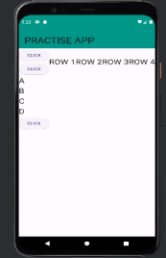

);

}

}

import 'package:flutter/material.dart';

void main() {

runApp(const MyApp());

}

class MyApp extends StatelessWidget {

const MyApp({super.key});

@override

Widget build(BuildContext context) {

return MaterialApp(

title:'flutter demo',

debugShowCheckedModeBanner: false,

theme:ThemeData(

primarySwatch:Colors.*lightBlue*,

),

home:const MyHomePage(),

);

DEPARTMENT OF SOFTWARE ENGINEERING MOBILE APPLICATION DEVELOPMENT (SE-487)

}

}

class MyHomePage extends StatefulWidget {

const MyHomePage({Key?key}):super(key:key);

@override

State<MyHomePage> createState() => _MyHomePageState(); }

class _MyHomePageState extends State<MyHomePage>

{

@override

Widget build(BuildContext context) {

return Scaffold(

appBar: AppBar(

backgroundColor: Colors.*teal*,

title: Text('PRACTISE APP',style: TextStyle(fontSize: 30),),

),

body:

Container(

//height: 300,

//width:300,

child: Column(

mainAxisAlignment: MainAxisAlignment.start, crossAxisAlignment: CrossAxisAlignment.start ,

children: <Widget> [

Row(

mainAxisAlignment: MainAxisAlignment.spaceEvenly, children:<Widget>

[

Column(

children: [

ElevatedButton(onPressed:(){print('hello');},

child:Text('CLICK')),

ElevatedButton(onPressed:(){print('hello');}, child:Text('CLICK')),

]

),

Text('ROW 1',style:TextStyle(fontSize: 25),), Text('ROW 2',style:TextStyle(fontSize: 25),), Text('ROW 3',style:TextStyle(fontSize: 25),), Text('ROW 4',style:TextStyle(fontSize: 25),), ],

),

DEPARTMENT OF SOFTWARE ENGINEERING MOBILE APPLICATION DEVELOPMENT (SE-487)

Text('A',style:TextStyle(fontSize: 25),), Text('B',style:TextStyle(fontSize: 25),), Text('C',style:TextStyle(fontSize: 25),), Text('D',style:TextStyle(fontSize: 25),), ElevatedButton(child: Text('CLICK'),onPressed:(){

print('hello');

},),

],

),

)

);

}

}

**Overflow Handling:** If the children of a Column/Row exceed the available vertical space, the overflow behavior can be controlled using properties such as mainAxisSize and overflow.

DEPARTMENT OF SOFTWARE ENGINEERING MOBILE APPLICATION DEVELOPMENT (SE-487)

**Exercise**

**Make layouts as shown below. Set the app title to your name.**

1. **Code**
2. //Musadique Hussain SE-21031
3. //Muhammad Asim SE-21045
4. import 'package:flutter/material.dart';
5. void main() {
6. runApp(const MyApp());
7. }
8. class MyApp extends StatelessWidget {
9. const MyApp({super.key});
10. @override
11. Widget build(BuildContext context) {
12. return MaterialApp(
13. title: 'Rows and Columns Lab',
14. debugShowCheckedModeBanner: false,
15. theme: ThemeData(
16. primarySwatch: Colors.blue,
17. ),
18. home: const MyHomePage(),
19. );
20. }
21. }
22. class MyHomePage extends StatelessWidget {
23. const MyHomePage({super.key});
24. @override
25. Widget build(BuildContext context) {
26. return Scaffold(
27. appBar: AppBar(
28. title: const Text('Rows and Columns Lab'),
29. ),
30. body: Center(
31. child: Column(
32. mainAxisAlignment: MainAxisAlignment.center,
33. children: <Widget>[
34. const Text(
35. 'Welcome to Rows and Columns Lab',
36. style: TextStyle(fontSize: 20,),
37. textAlign: TextAlign.center,
38. ),
39. const SizedBox(height: 10),
40. const Text(
41. 'This is a simple Flutter app\nExplore the power of rows and columns',
42. style: TextStyle(fontSize: 16),
43. textAlign: TextAlign.center,
44. ),
45. const SizedBox(height: 20),
46. Row(
47. mainAxisAlignment: MainAxisAlignment.center,
48. children: <Widget>[
49. ElevatedButton(
50. onPressed: () {},
51. child: const Text('Next'),
52. ),
53. const SizedBox(width: 10),
54. ElevatedButton(
55. onPressed: () {},
56. child: const Text('Back'),
57. ),
58. ],
59. ),
60. ],
61. ),
62. ),
63. );
64. }
65. }

**Output**

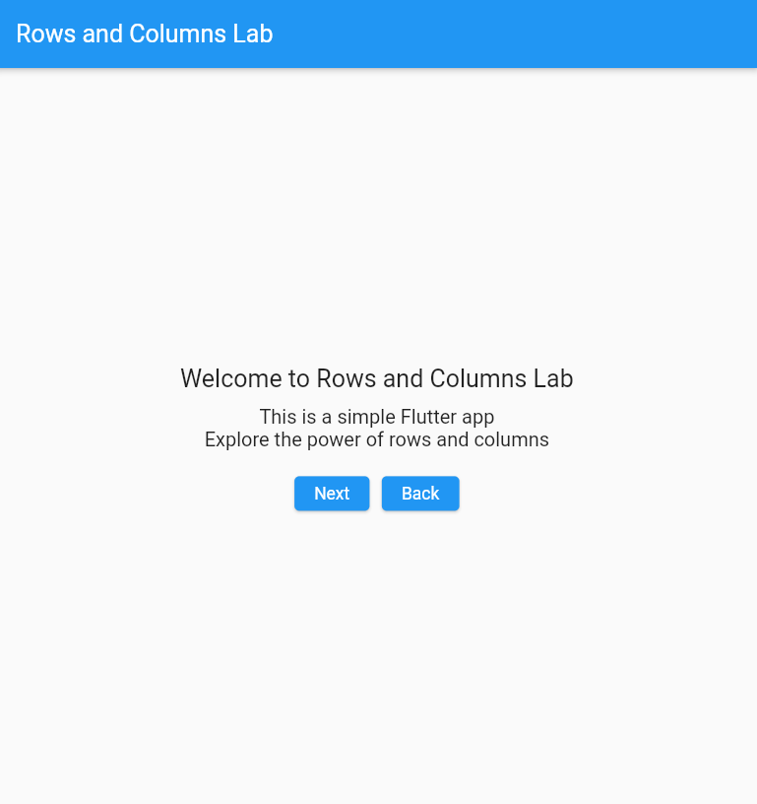

2) Code

//Musadique Hussain

//Muhammad Asim

import 'package:flutter/material.dart';

void main() {

  runApp(const MyApp());

}

class MyApp extends StatelessWidget {

  const MyApp({super.key});

  @override

  Widget build(BuildContext context) {

    return MaterialApp(

      title: 'Nested Rows and Columns',

      debugShowCheckedModeBanner: false,

      theme: ThemeData(

        primarySwatch: Colors.blue,

      ),

      home: const MyHomePage(),

    );

  }

}

class MyHomePage extends StatelessWidget {

  const MyHomePage({super.key});

  @override

  Widget build(BuildContext context) {

    return Scaffold(

      appBar: AppBar(

        title: const Text('Nested Rows and Columns'),

      ),

      body: Center(

        child: Column(

          mainAxisAlignment: MainAxisAlignment.center,

          children: <Widget>[

            Row(

              mainAxisAlignment: MainAxisAlignment.center,

              children: <Widget>[

                ElevatedButton(

                  onPressed: () {},

                  child: const Text('Button 1'),

                ),

                const SizedBox(width: 20),

                ElevatedButton(

                  onPressed: () {},

                  child: const Text('Button 2'),

                ),

              ],

            ),

            const SizedBox(height: 20),

            Row(

              mainAxisAlignment: MainAxisAlignment.center,

              children: <Widget>[

                SizedBox(

                  width: 150,

                  child: TextField(

                    decoration: const InputDecoration(

                      labelText: 'Text Field 1',

                    ),

                  ),

                ),

                const SizedBox(width: 20),

                SizedBox(

                  width: 150,

                  child: TextField(

                    decoration: const InputDecoration(

                      labelText: 'Text Field 2',

                    ),

                  ),

                ),

              ],

            ),

          ],

        ),

      ),

    );

  }

}

Output

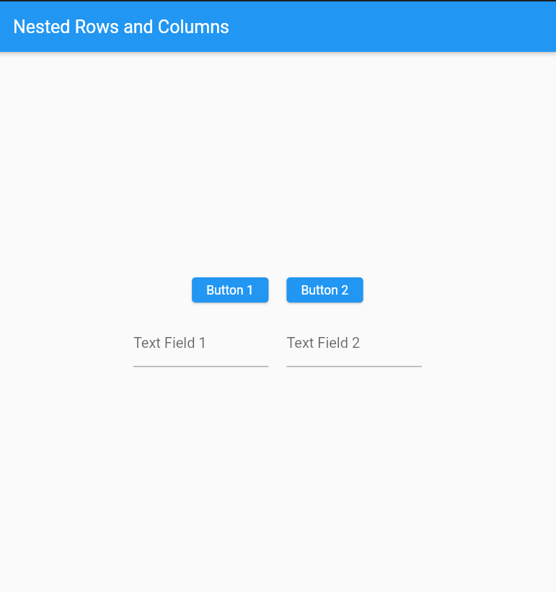

3) Code

//Musadique Hussain SE-21031

//Musadiuqe Hussain SE=21045

import 'package:flutter/material.dart';

void main() {

  runApp(MyApp());

}

class MyApp extends StatelessWidget {

  @override

  Widget build(BuildContext context) {

    return MaterialApp(

      debugShowCheckedModeBanner: false,

      title: 'Layouts Demo',

      theme: ThemeData(

        primarySwatch: Colors.orange,

      ),

      home: ColoredBarsScreen(),

    );

  }

}

class ColoredBarsScreen extends StatelessWidget {

  @override

  Widget build(BuildContext context) {

    return Scaffold(

      appBar: AppBar(

        title: Text('Flutter Demon HomePage'),

      ),

      body: Column(

        children: [

          Expanded(child: Container(color: Colors.red)),

          Expanded(child: Container(color: Colors.green)),

          Expanded(child: Container(color: Colors.blue)),

          Expanded(child: Container(color: Colors.yellow)),

          Expanded(child: Container(color: Colors.orange)),

          Expanded(child: Container(color: Colors.purple)),

          Expanded(

            child: Row(

              children: [

                Expanded(child: Container(color: Colors.pink)),

                Expanded(child: Container(color: Colors.lightBlue)),

                Expanded(child: Container(color: Colors.lime)),

                Expanded(child: Container(color: Colors.indigo)),

              ],

            ),

          ),

        ],

      ),

    );

  }

}

Output

